Ideation Phase
Define the Problem Statements

Date | 31 January 2025
Team ID
Project Name | AI Enabled student Admission System
Maximum Marks | 2 Marks

Customer Problem Statement Template:
Create a problem statement to understand your customer's point of view. The Customer Problem Statement template helps you focus on what matters to create experiences people will love.
Problem Statement
To capture operational gaps experienced by diverse university actors, the formal framework below lists specific operational friction points:
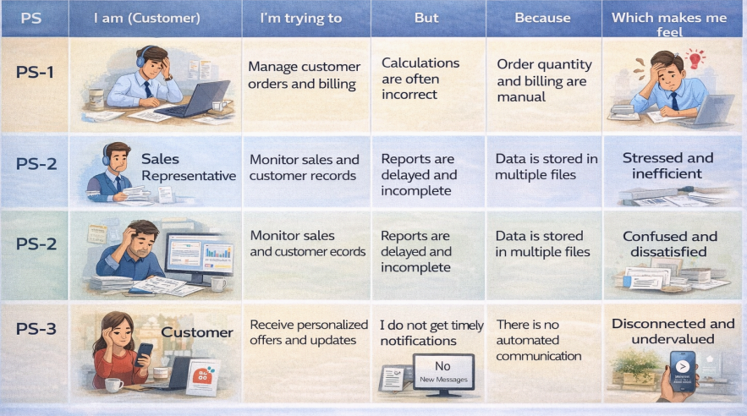

PS ID | I am (Persona) | I'm trying to... | But encounter friction because... | Which makes me feel...
PS-1 | Admission Officer | Process hundreds of high-volume applicant files, cross-verify academic indexes, and calculate complex multi-tiered fee balances. | Calculations are manually driven via local spreadsheets, causing human clerical flaws, transcript backlog delays, and math errors. | Stressed, operationally bottlenecked, and prone to administrative inefficiencies.
PS-2 | College Dean / Director | Monitor daily intake trends, isolate departmental capacity, filter application status splits, and inspect fiscal fee collection tallies. | Operational records are scattered over physical files and legacy local systems, rendering structural reports heavily delayed and incomplete. | Confused, decoupled from active metrics, and dissatisfied with insight generation timelines.
PS-3 | Student Applicant | Submit registration records, look up appropriate eligible tracks, track document screening status, and execute prompt tuition fee balances. | There is no automated communication, leading to non-existent visibility and extended periods of waiting without alert notifications. | Disconnected, anxious, undervalued by the university, and left in total processing dark.

